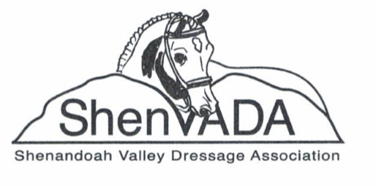
ShenVADA Dressage Schooling Show at Cedar Creek Stables
Saturday, September 17, 2022
Judge: Nancy Lowey “R”
Entries must be submitted by Monday, Sept. 12th. Ride times will be emailed & posted Shen-VADA.com
**USDF Regional Schooling Awards Program Participating Competition**
Tests Offered: USDF Intro, USEF Training to Fourth, FEI TOC, USEA TOC, WDAA
Show Manager: Annette Hildabrand, 703-622-8130, hildabrandvet@gmail.com
Show Secretary: Erin Fitzwater, 703-966-0875, cgent76@gmail.com
To enter online: www.bluehorseentries.com or email entry and Coggins to Show Secretary
Fee Per Test – ShenVADA Member: $35.00 Non-Members: $45.00
Awards: 1st – 4th place ribbons and High Score Prize for Show (excludes Intro Level)

Rider Name: __________________________________________ Phone: ______________________
Email Address (required): _______________________________
Address: ____________________________________________________________________________
Rider Status: JR or SR Rider USDF # (for USDF Regional Schooling Show Program): _________________
Owner Name (If different from Rider): _____________________________________
Owner USDF # (for USDF Regional Schooling Show Program): ___________________
Horse Name (must match Coggins): ____________________________________________
Horse USDF # (for USDF Regional Schooling Show Program):
Test 1: _________________ Test 2: ___________________ Test 3: ___________________
Total Amount Due: _______________

Address for Cedar Creek Stables: 2435 Shutterlee Mill Rd., Staunton, VA
The following must be sent to the secretary on the prize list: (1) this completed Entry Form (2) a legible copy of the horse’s Coggins report that will be current on the date of the show and has the same horse name as on this entry form, (3) check for the total amount due (made out to ShenVADA), (4) Liability forms to be signed when checking in at the show.

